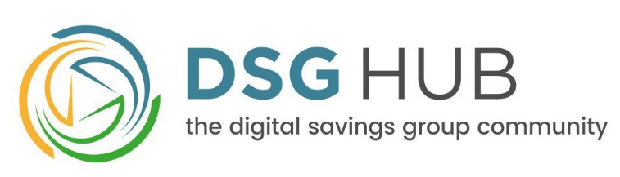

Digital Savings Group (DSG) Hub
Content templates & filters
July 2016

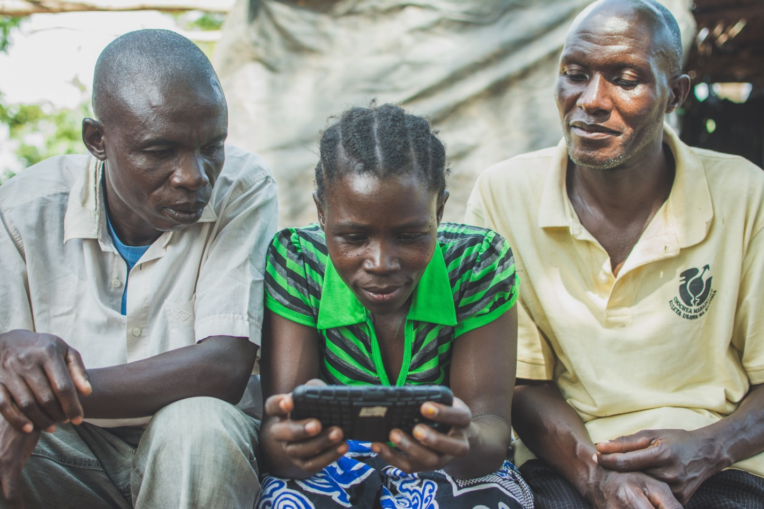

Content Submission Guidelines

April 2022

Table of Contents

About the DSG Hub 1
A Note to Community Contributors 2
Guest Blog Post Template 3
Resource Template 5
‘Technology Solutions Overview’ Template 8
Filters & Tags 11

About the DSG Hub

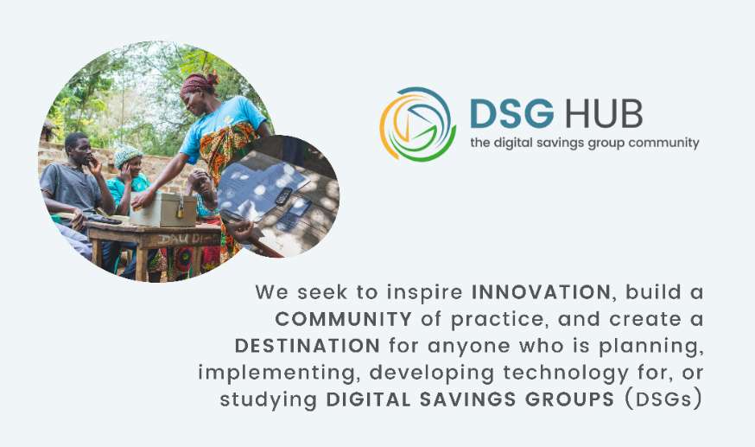
The Digital Savings Group (DSG) Hub is an online learning and community platform aimed at facilitating thoughtful, safe, and inclusive digitization of savings groups. The overall goal of the Hub is to help actors make sound decisions about whether and how to digitize savings groups effectively. The DSG Hub contains a wide variety of practical, easy-to-find, and easy-to-use resources to support savings group members and practitioners on their digitization journeys. The DSG Hub also serves as a tool for an ongoing community engagement, allowing diverse actors from across the industry to connect with one another, share insights and experiences, and learn from successes and shortcomings in the sector. The project is funded by the FAHU Foundation and implemented by Global Communities.

FAHU Foundation strives to create lasting sustainable development by supporting innovative interventions which address the root causes of poverty. The Foundation focuses on building social and economic resilience and improving the lives of poor and marginalized people in sub-Saharan Africa through the savings group model.

Global Communities works at the nexus of humanitarian assistance, sustainable development, and financial inclusion, reaching millions of people with community-based programs in more than 35 countries. We bring together local ingenuity and global insights to save lives, advance equity, and secure strong futures.

Contact. For further information, please visit www.DSGHub.org or contact us at info@DSGHub.org.

Cover page photo: Participants of Global Communities’ savings group digitization pilot in Tanzania. Photo courtesy of Tony Tseng.

A Note to Community Contributors

Thank you for developing content for the DSG Hub. We encourage Community Contributors to use our customizable content templates presented in this document. These templates help ensure that the proposed content meets our Content Submission Guidelines and publication criteria.

Regardless if the proposed template is used, we strongly encourage submissions developed with the author’s own voice and submitted in the style and format of the contributor. We also encourage contributors to select filters and tags presented at the bottom of this document to help users find the blog post or resource easily.

We look forward to your submission!
DSG Hub Editorial Team

Guest Blog Post Template

Please review the DSG Hub Content Submission Guidelines before drafting a guest blog post for the Hub. All original guest blog posts must include all required components outlined in this template.

Basic Information

Title | Insert concise headline which is both informative and will capture readers’ attention.
Subtitle (if any) | This is an optional field.
Individual author(s) | Insert full name in natural order, usually First and Last Name. If there are multiple authors, separate them with commas.
About the author(s) | Include one short paragraph describing the author(s) professional affiliation and background (up to 50 words).
Author’s photograph | Attach a high-resolution photo(s) (preferably a headshot) of the author(s) for inclusion on the blog post.
Photographs & other audiovisual content | Attach at least one content-related photograph that will accompany the blog post. Note that all photographs, (info)graphics, videos, and other audiovisual material must be adequately credited. Authors are responsible for ensuring that all proposed audiovisual content is ethically sourced, edited, and used.
Date of submission

Abstract

- Each blog post will have a “resource card” with a short abstract posted in our “resource library.”
- A blog post abstract should be written in English, self-contained, understandable to a wide audience, and succinct, i.e., no longer than one paragraph and 100-150 words.
- Each abstract should begin with an introduction (one self-contained sentence) and briefly explain the salient aspects of the content, i.e., a) main purpose; b) key takeaways and their significance for the DSG community; and c) a specific audience (e.g., technology providers) who will find the content most useful.
- Abstracts should avoid abbreviations and should not include citations.

……………………………………………………………………………………………………………………………………………………………………………………………………………………
……………………………………………………………………………………………………………………………………………………………………………………………………………………

Body of the Blog Post

Each blog post should be between 300 and 1,500 words. Please aim for 600 to 1,000 words. For longer blog posts, we encourage authors to use headings and sub-headings to break up the text.

Engaging Introduction

……………………………………………………………………………………………………………………………………………………………………………………………………………………
……………………………………………………………………………………………………………………………………………………………………………………………………………………

Main Section

……………………………………………………………………………………………………………………………………………………………………………………………………………………
……………………………………………………………………………………………………………………………………………………………………………………………………………………

Conclusion

……………………………………………………………………………………………………………………………………………………………………………………………………………………
……………………………………………………………………………………………………………………………………………………………………………………………………………………

Key Takeaways
Include 2-3 short bullet points with information that you would like the reader to remember after reading the blog post.

- [Key takeaway no. 1]
- [Key takeaway no. 2]
- [Key takeaway no. 3]

Take Action
Insert 2-3 short bullet points giving advice or recommendations to readers (e.g., “do” or “don’t”), calling readers to action (e.g., “support,” “demand,” “advocate for”), or simply referring readers to other information (e.g., “read more,” “listen to”).

- [Action no. 1]
- [Action no. 2]
- [Action no. 3]

Resource Template

The DSG Hub will publish a wide range of high-quality resources of relevance to the DSG community, including learning briefs, case studies, DSG member stories, decision trees, flowcharts, infographics, presentations, videos, interviews, how-to guides, and tip sheets. If you are developing a resource with the DSG Hub in mind, we encourage you to use this template as a guide, but this is not required. While we do not intend to develop a template for each type of resource, we recommend incorporating information specified below to make each resource as practical and easy to use as possible. Please review the DSG Hub Content Submission Guidelines before developing the resource.

Basic Information

Title | Insert a concise title which is both informative and will capture readers’ attention.
Subtitle (if any) | This is an optional field.
Individual author(s) | Insert full name in natural order, usually First and Last Name. If there are multiple authors, separate them with commas
Publisher / institutional author(s) | Insert name of the institution(s) which developed and/or published the resource
Date of submission

Abstract

- Each resource will have a “resource card” with a short abstract posted in our “resource library.”
- A resource abstract should be written in English, self-contained, understandable to a wide audience, and succinct, i.e., no longer than 1-2 paragraphs and 100-300 words.
- Each abstract should begin with an introduction (one self-contained sentence) and briefly explain the salient aspects of the content, i.e., a) main purpose; b) key takeaways or lessons learnt and their significance for the DSG community; and c) a specific audience (e.g., technology providers) who will find the content most useful.
- Abstracts should avoid abbreviations and should not include citations.

……………………………………………………………………………………………………………………………………………………………………………………………………………………
……………………………………………………………………………………………………………………………………………………………………………………………………………………

Body of the Resource

Introduction

Include a concise introduction focusing on the following questions:

WHAT & WHY | What is the resource about and why was it created? Briefly describe the resource, focusing on its type and format (e.g., training manual or learning brief), purpose, and relevance for the DSG community.
WHO | Who is the resource intended for? Be very specific about the audience who will find the resource most useful (e.g., DSG program managers or trainers)
WHERE | What is the geographic scope of the resource? Where was it created, used, tested, or implemented? Is it adaptable to other contexts?
WHEN | At which stage of the DSG project should the resource be used? How much time is needed to read, use, or implement the resource?
HOW | How should the resource be used? Provide clear, step-by-step guidance on how to use the resource in the most optimal way. If feasible, specify the costs, materials, and other resources needed to implement it.

Main Section

……………………………………………………………………………………………………………………………………………………………………………………………………………………
……………………………………………………………………………………………………………………………………………………………………………………………………………………

Key Takeaways or Lessons Learnt
Include 2-3 short bullet points with information that you would like the reader to remember after reading the resource.

- [Key takeaway no. 1]
- [Key takeaway no. 2]
- [Key takeaway no. 3]

Recommendations
Insert 2-3 short bullet points with recommendations for the readers.

- [Recommendation no. 1]
- [[Recommendation no. 2]
- [Recommendation no. 3]

Citations (Footnotes, Endnotes, or Bibliography)
Provide citations to external sources used to develop the resource.

Conclusion

……………………………………………………………………………………………………………………………………………………………………………………………………………………
……………………………………………………………………………………………………………………………………………………………………………………………………………………

Branding, Acknowledgments, and Disclaimers

Please use your own institution’s branding and standard language for acknowledgments and disclaimers. If you do not have it, please feel free to use the following templates to develop them.

- Sample disclaimer. The [title] was financed by [donor], through a grant provided to [institution]. The statements contained in this resource are the work of [authors and/or institutions] and do not necessarily reflect the views or policies of [institution, e.g., donor]. Responsibility for any errors, interpretations, or omissions lies solely with the authors.

- Sample acknowledgments. The [title of the resource] was created [authored/developed/written] by [names and titles] at [institutions]. [Names, titles, institutions] oversaw the development of the resource and provided substantive and editorial support. This work would not have been possible without the contributions of numerous individuals. The authors are grateful for the time rendered by those who [reviewed, edited, translated] the resource, including [names, titles, institutions]. Special thanks go out to community members in [country, town, village] who so willingly shared their time and insights with us. Last but not least, we wish to sincerely thank [donor] for funding [name of the project] through which this resource was developed.

- Sample copyright/credit language. Copyright © [year] [institution]. Sections of this publication may be reproduced, distributed, or adapted for non-commercial purposes without permission from [institution]. Please credit [institution] where any such use involves publishing a part of this resource. For further information, please contact us at [contact information]. Cover page photo: [description]. Photo courtesy of [name of photographer].

‘Technology Solutions Overview’ Template

One of the core components of the DSG Hub is an overview of DSG technology solutions. This online catalog features leading DSG solutions in a clear, succinct, and comparable format that is accessible to diverse stakeholders, including international and local non-governmental organizations (NGOs), financial service providers, technology service providers, funders, investors, and governments. The DSG Hub is seeking submissions from leading DSG technology providers to be added to the online catalog. Please review the DSG Hub Content Submission Guidelines before preparing this submission.

PART A: CONTRIBUTOR SURVEY

Please answer all questions as succinctly as possible, in no more than a few words. Detailed explanations may be provided in the product description (Part B).

CONTACT PERSON

Contact information will not be published or shared with any third parties and is for the internal records of the DSG Hub only.

- Name:
- Position:
- Organization:
- Email:

ORGANIZATION

- Name:
- Stakeholder type (NGO, financial service provider, technology service provider, mobile network operator, social enterprise, etc.):
- Country of registration:
- Website:
- Contact (generic ‘info’ or ‘customer support’ email or link to the organization’s ‘contact us’ page that can be published on the DSG Hub):

SOLUTION OVERVIEW

- Product name:
- Functionalities (check all that apply to the product, at present):
- Digital records ☐
- Group procedures (meeting procedures, elections, constitution, share-out, etc.) ☐
- Calculations (outstanding loan balances, fund balances, member payouts, etc.) ☐
- Electronic payments and digital money storage ☐
- Digital financial services
  - Provided directly by the DSG service provider ☐
  - Provided by partner financial institution(s) ☐
  - Peer-to-peer (group-to-group) lending ☐
- Credit scoring ☐
- Online marketplace (financial or non-financial services) ☐
- eLearning
- Digital training for Savings Groups ☐
- Digital platform for skills development in other areas ☐
- Remote monitoring (data collection and analytics) ☐
- Communication
- Short messages (SMS) to members (transaction receipts, personal/group balances, reminders, etc.) ☐
- In-app messaging
    - Group-to-group messaging ☐
    - Institution-to-group messaging ☐
- Micro-surveys ☐
- Other (please specify):
- Languages
- Available languages:
- Estimated cost of translation to an additional language (in USD):
- Hardware requirements
- Group:
- End user (DSG member):
- Connectivity requirements
- Network requirements:
- Off-line capabilities:
- Cumulative outreach
- Countries:
- Number of institutional users (organizations), disaggregated by country:
- Number of groups, disaggregated by country:
- Number of end users (group members), disaggregated by country:
- Costs
- Institutional user
  - Fixed costs (type and estimated amount in USD):
  - Variable costs (type and estimated amount in USD):
- Group
  - Fixed costs (type and estimated amount in USD):
  - Variable costs (type and estimated amount in USD):
- End user (DSG member)
  - Fixed costs (type and estimated amount in USD):
  - Variable costs (type and estimated amount in USD):
- Download link:

PART B: Solution Description

Please include a brief description of the solution (400-500 words). The DSG Hub is committed to diversity, inclusion, and accessibility. We encourage content submissions in the author’s own voice and style. For the purposes of consistency and comparability, we strongly encourage contributors to develop their respective solution descriptions based on their responses to the survey in PART A. In addition, consider specifying:

- Evidence of impact
- Client protection measures, including data privacy and security
- Key risks and barriers to adoption
- Plans for the next 2-3 years in terms of product development, scale up, geographic expansion, or partnership development.

Please be as specific and succinct as possible, and refrain from generic statements and overly promotional language.

PART C: Supporting Resources

Please attach (or provide links to):

- Logo of the organization or product (as you would like it displayed in the “Technology Solutions Overview”)

- 2-3 high resolution pictures
  - At least one action shot of the technology being used by an institutional or end user
  - At least one close-up image (picture or animated figure) of the technology

- 1-3 supporting resources (this may include, for example, user guides, training videos, promotional videos, case studies, presentations, or research).

Filters & Tags

Filters

User Journey

☐ Get started with digital technology
☐ Implement digital savings groups projects
☐ Examine learning and evidence

FILTER BY TOPIC

[Please select no more than 3 topics that best describe the resource]

☐ Technology Solutions
☐ Benefits of Digitization
☐ Risks & Barriers to Digitization
☐ Digital Inclusion
☐ Financial Inclusion
☐ Gender & Social Inclusion
☐ Consumer Protection
☐ Industry Standards & Regulations
☐ Other (please specify): ……………………………………………………………………

FILTER BY DSG Project CYCLE

[Please select all that apply]

☐ Planning & Project Design
☐ Project Implementation
☐ Monitoring, Evaluation & Learning

FILTER BY Resource Type

[Please select one that best describes the resource]

☐ DSG Hub Blog
☐ Blog Post
☐ Article
☐ Research
☐ Tool
☐ Training
☐ Brief
☐ Multimedia

FILTER BY Region

[Please select all that apply]

☐ Global

☐ North America
☐ Latin America & the Caribbean
☐ Europe & Central Asia
☐ Middle East & North Africa
☐ Sub-Saharan Africa
☐ Asia Pacific

FILTER BY Language

[Please select one]

☐ English
☐ Spanish
☐ French
☐ Arabic
☐ Other [please specify]: ………………………………………………………………

FILTER BY Publication Date

[Please select one]

☐ Before 2015
☐ 2015-2020
☐ After 2020

Tags

[Please select no more than 10 tags TOTAL. You may propose new tags that are currently not listed. Please highlight secondary tags (beyond the 10 limit) in yellow]

New proposed tags (if any): ……………………………………………………………………………………………………………………………………………….

Technology Sector

☐ Technology Solutions
☐ Digital Literacy
☐ Digital Inclusion
☐ Digital Recordkeeping
☐ Digital Payments
☐ Innovation
☐ FinTech
☐ Mobile Device
☐ Mobile Phone Access
☐ Internet Access
☐ Digital Transformation

Financial Sector

☐ Financial Service Providers
☐ Formal Finance
☐ Informal Finance
☐ Financial Literacy
☐ Financial Inclusion
☐ Financial Products & Services
☐ Digital Financial Services
☐ Mobile Money

DSG Implementation

☐ Digitization Planning
☐ Project Design
☐ Project Budgeting
☐ Project Implementation
☐ Risk Management
☐ Human Resources
☐ Training
☐ Research & Analysis
☐ Monitoring & Evaluation
☐ Evidence & Impact

DSG User Experience, Benefits & Risks

☐ User Experience
☐ Digitization Benefits
☐ Digitization Risks & Barriers
☐ Digitization Costs
☐ Digital Identity
☐ Data Privacy & Security
☐ Personal Security
☐ Security of Funds
☐ Social Cohesion
☐ Peer Learning
☐ Ethics
☐ Consumer Protection
☐ Customer Service
☐ Technology-Facilitated Abuse

Gender & Social Inclusion

☐ Gender
☐ Social Inclusion
☐ Youth & Children
☐ Migrants & Refugees
☐ Aging & the Elderly
☐ Disability
☐ Literacy & Numeracy
☐ Rural Populations
☐ Urban Populations
☐ Digital Divide

Industry Standards & Regulations

☐ Law & Policy
☐ Governance
☐ Industry Standards
☐ Program Quality

Other

☐ COVID-19
☐ Shocks & Stresses
☐ Resilience
☐ Economic Development
☐ Urban Development
☐ Rural Development
☐ Community Engagement
☐ Change Management

